Preview of table regions before normalization:

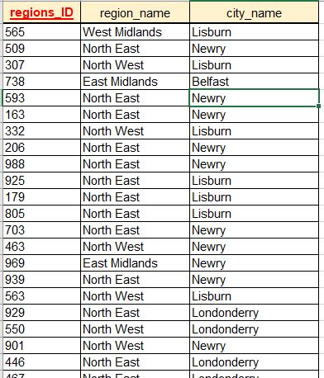

Table is already in 3NF.

PK is region_ID.